SCHOOL OF COMPUTER SCIENCE AND ARTIFICIAL INTELLIGENCE |  |  |  |  | DEPARTMENT OF COMPUTER SCIENCE ENGINEERING
ProgramName:B. Tech |  |  |  | SET-B |  |  | AcademicYear:2025-2026
Roll No.
Instructor(s)Name |  |  |  | - Dr. Venkataramana  - Dr. Ch. Sridhar  - Mr. Kundan Kumar
CourseCode |  |  | 24CS002PC215 | CourseTitle |  | AI Assisted Coding
Year/Sem |  |  | II/I | Regulation |  | R24
Date and Day  of Assignment |  |  | 22.08.2025 | Time(s) |  | 01.00PM To 03.00PM
Duration |  |  | 2 Hours | Applicableto  Batches |  | 24BTCAIAIB09, 24BTCAIAIB10
Lab Test :1(Present test number)/4(Total number of tests)
 | Q.No. | Question |  |  |  |  |  | ExpectedTime  to complete
 | 1 | Task Description#1  - Write python program for a function factorial_febo(n) that return both factorial of given number and Fibonacci series as per input “n”  Expected Output#1  - factorial_febo(n) and output  - prompt:- Write a Python function called factorial_febo(n) that returns both the factorial of the number n and the Fibonacci series up to n terms, and demonstrate its output for n = 3, n = 5, and n = 7.  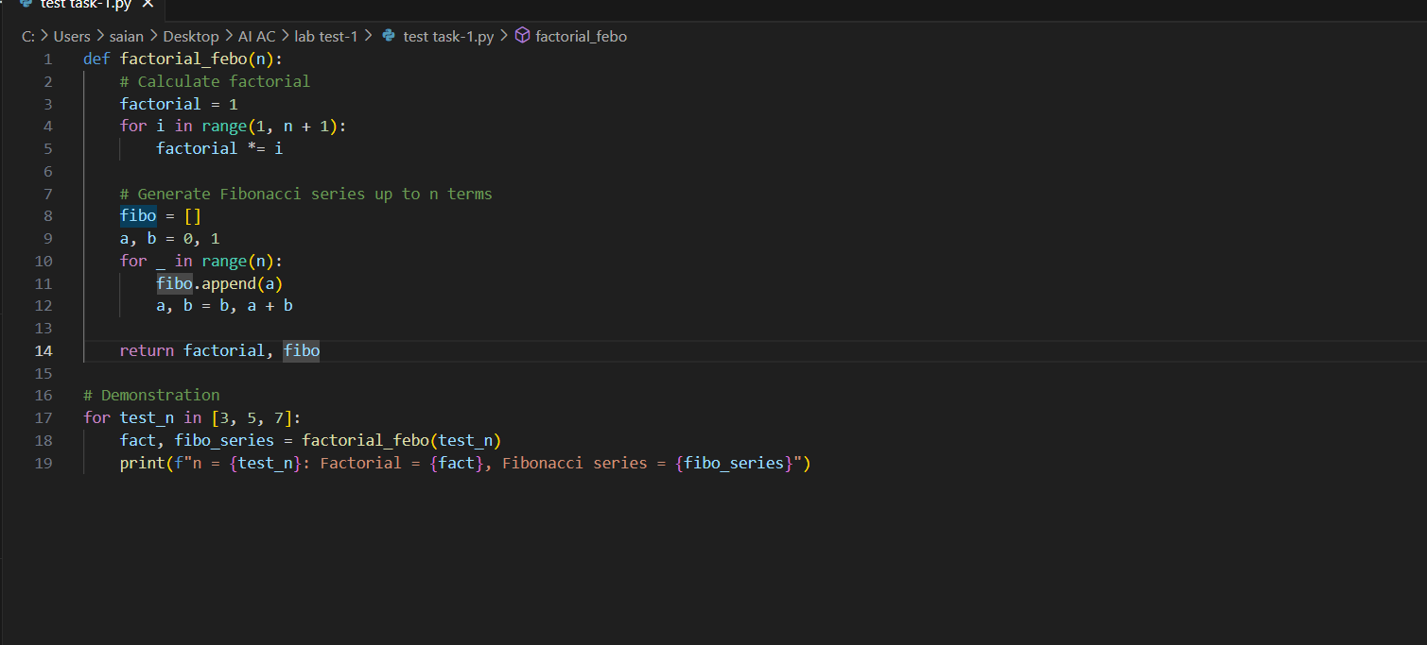  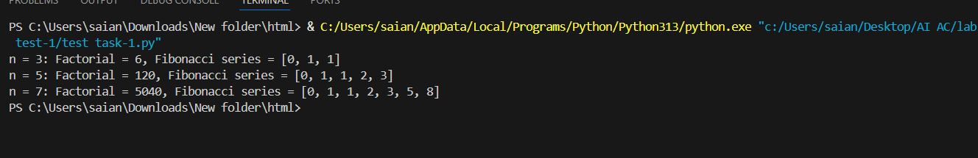  Task Description#2  - Write Python program in cursor AI for student class with attributes like Name, Roll no, Marks and also construct a method i.e., display_details to display name, rollno, marks and grades  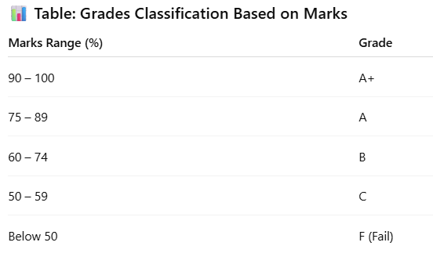  Expected Output#2  - Student Class and Display Details  - Prompt:- Write a Python program that defines a Student class with attributes for name, roll number, and marks, and includes a method display_details() to show the student's name, roll number, marks, and grade based on the following classification: A+ for 90–100%, A for 75–89%, B for 60–74%, C for 50–59%, and F for below 50%.  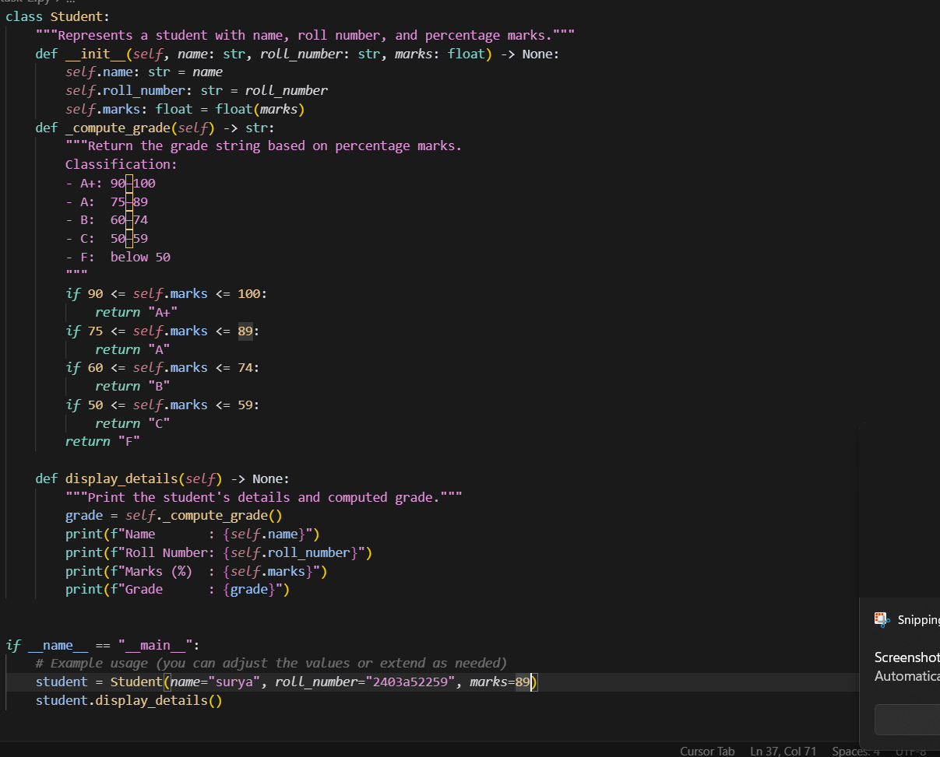  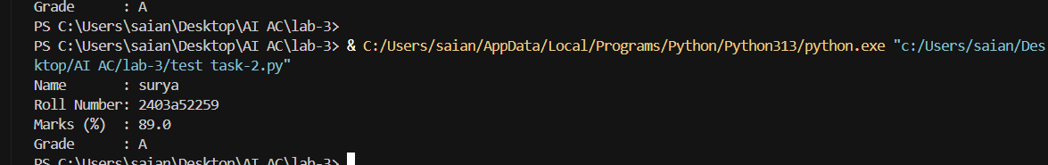  Note: Report should be submitted a word document for all tasks in a single document with prompts, comments & code explanation, and output screenshots  Evaluation Criteria:  Criteria Max Marks  Factorial Function (Task#1) 5  Sorting Function (Task#2) 5  Viva 5  Total 15 Marks |  |  |  |  |  | 22.08.2025 03.00PM

